NAME: GURUPRASATH.S
REG NO:192411270L
SUB NAME: COMPUTER VISION
SUB COD: ITA0502
EX NO:6

AIM

To read an image in Python and perform erosion using the cv2.erode() function in OpenCV..

ALGORITHM
- Start the program.
- Import OpenCV and NumPy.
- Give the complete path of the input image.
- Read the image.
- Create a kernel.
- Apply the erosion operation.
- Display the original and eroded images.
- Stop the program
PROGRAM:
import cv2
import numpy as np
image = cv2.imread(r"D:\ITA 05\street-lamps-at-violet-sunset.jpg")
if image is None:
print("Error: Image not found!")
else:
kernel = np.ones((5, 5), np.uint8)
eroded = cv2.erode(image, kernel, iterations=1)
cv2.imshow("Original Image", image)
cv2.imshow("Eroded Image", eroded)

cv2.waitKey(0)
cv2.destroyAllWindows()

sample input:


SAMPLE OUTPUT:
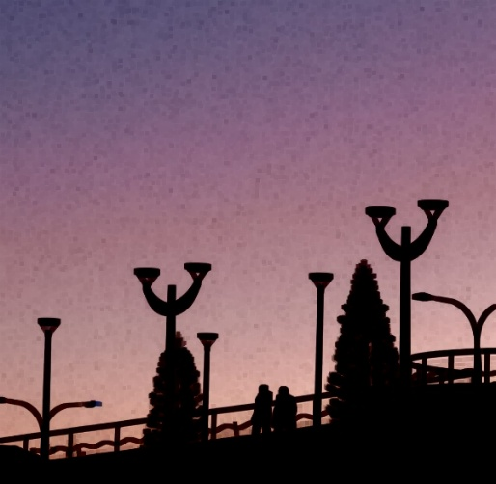

RESULT
Thus, the input image was successfully read and the erosion operation was performed using cv2.erode() in OpenCV.

